Adding Payment details
Partners will see this page on their first instance:
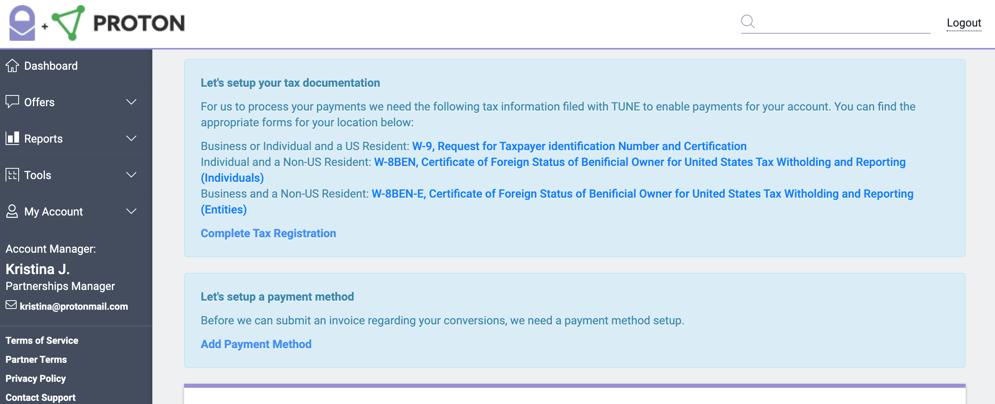
Partners need to click on either “Complete Tax Registration” or “Add Payment Method”, where they MUST add their Tax ID (or TIN) and attach the W8-BEN, W8-BEN-E or W-9 form on the “Tax Information” area:
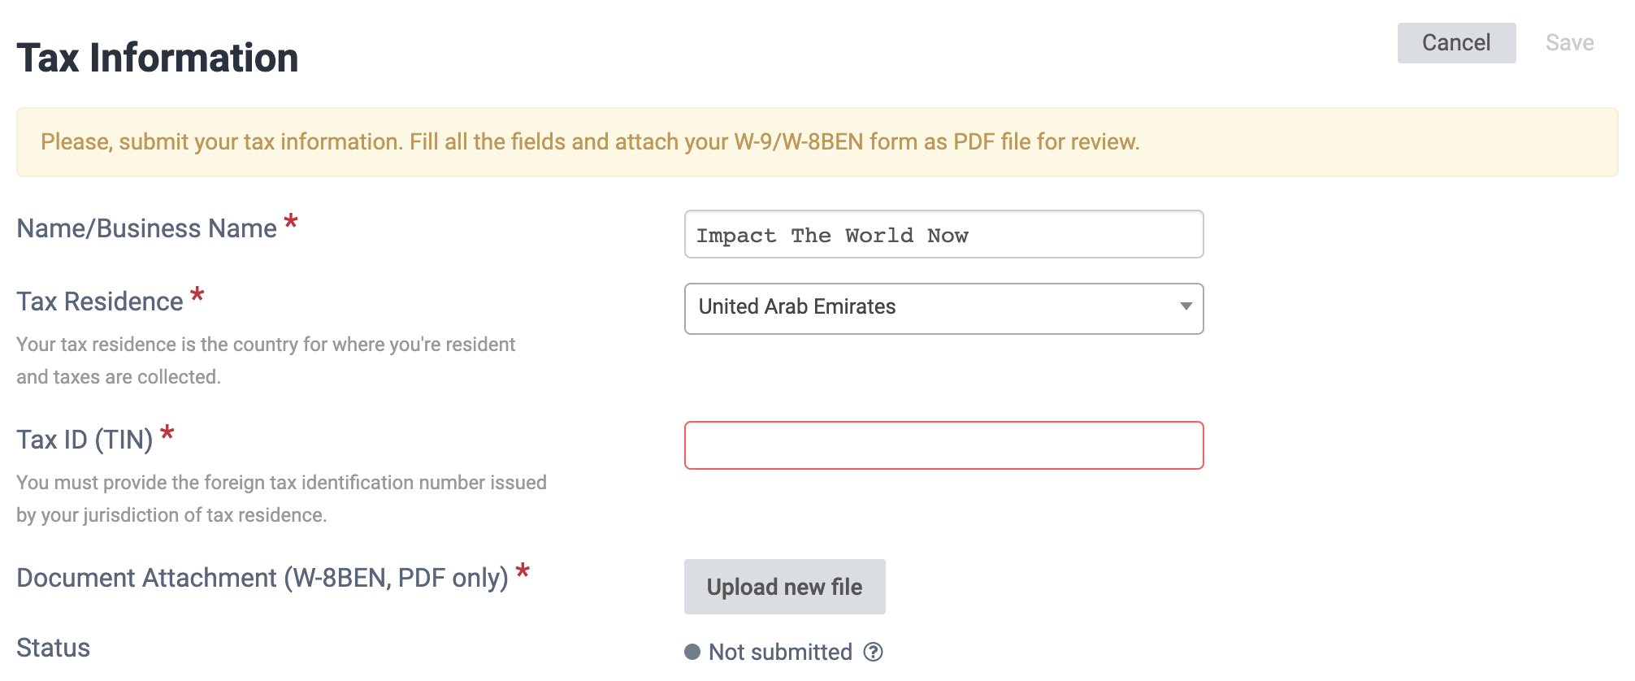

They must also add a payment method here:
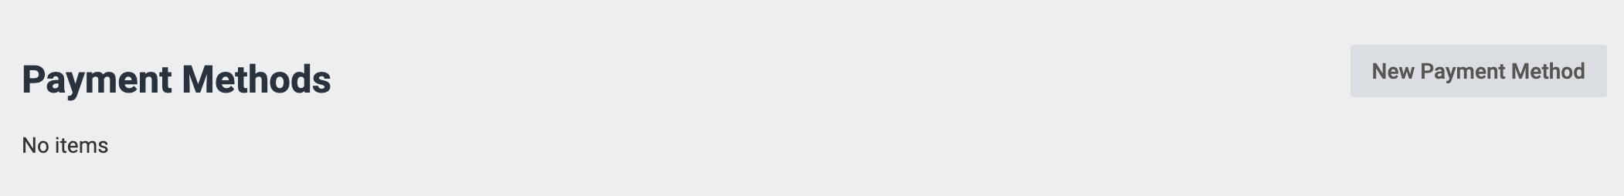

INSTRUCTIONS HOW TO FILL THE TAX DOCUMENTS
INDIVIDUAL AND NON-US RESIDENT W-8BEN
W-8BEN is used by foreign individuals who acquire various types of income from U.S. sources.

Where Can I Download Form W-8BEN?
America’s tax authority publishes all of its forms at www.irs.gov. The W-8BEN is available here.

How Do I Fill Out Form W-8BEN?
- Line 1: Enter your name.
- Line 2: Enter your citizenship. If you’re not a resident of the country where you have citizenship, you should enter your country of residence (instead of your country of citizenship). If you’re a dual citizen, you should enter the country where you are both a resident and a citizen on the date you complete the form
- Line 3: Enter your mailing address. For the purposes of W-8BEN, this is your tax home, which is where you reside for income tax purposes. It should be a permanent residence address and not a P.O. Box or address of a financial institution. Be sure to include your postal code.
- Line 6: Enter your foreign tax identifying number(TIN) You can google “what is the TIN in YOUR_COUNTRY” to find out the ID you need to add there
- Line 8: Enter your date of birth. Make sure it’s in mm-dd-yyyy format.
- Part III: Here, you’ll need to certify with your signature under penalties of perjury that everything on the form is true and correct.

BUSINESS AND NON-US RESIDENT W-8BEN-E

W-8BEN-E is used by foreign business entities who acquire various types of income from U.S. sources.

Where Can I Download Form W-8BEN-E? America’s tax authority publishes all of its forms at www.irs.gov. The W-8BEN-E is available at https://www.irs.gov/pub/irs-pdf/fw8bene.pdf

BUSINESS OR INDIVIDUAL AND A US RESIDENT W-9

